Botswana

## Population Data

The data set shows the political stability estimate of the country each year.

## # A tibble: 23 x 5  
## country iso3c date population popCategory5  
## <chr> <chr> <dbl> <dbl> <chr>   
## 1 Botswana BWA 1996 1504730 very small   
## 2 Botswana BWA 1997 1540425 very small   
## 3 Botswana BWA 1998 1575824 very small   
## 4 Botswana BWA 1999 1610264 very small   
## 5 Botswana BWA 2000 1643334 very small   
## 6 Botswana BWA 2001 1674678 very small   
## 7 Botswana BWA 2002 1704642 very small   
## 8 Botswana BWA 2003 1734398 very small   
## 9 Botswana BWA 2004 1765527 very small   
## 10 Botswana BWA 2005 1799078 very small   
## 11 Botswana BWA 2006 1835908 very small   
## 12 Botswana BWA 2007 1875459 very small   
## 13 Botswana BWA 2008 1915639 very small   
## 14 Botswana BWA 2009 1953498 very small   
## 15 Botswana BWA 2010 1987105 very small   
## 16 Botswana BWA 2011 2015402 very small   
## 17 Botswana BWA 2012 2039551 very small   
## 18 Botswana BWA 2013 2062536 very small   
## 19 Botswana BWA 2014 2088614 very small   
## 20 Botswana BWA 2015 2120716 very small   
## 21 Botswana BWA 2016 2159944 very small   
## 22 Botswana BWA 2017 2205128 very small   
## 23 Botswana BWA 2018 2254126 very small

## # A tibble: 23 x 5  
## country iso3c date popGrowth popGrowthCat5   
## <chr> <chr> <dbl> <dbl> <chr>   
## 1 Botswana BWA 1996 2.39 moderate growth rate  
## 2 Botswana BWA 1997 2.34 moderate growth rate  
## 3 Botswana BWA 1998 2.27 moderate growth rate  
## 4 Botswana BWA 1999 2.16 moderate growth rate  
## 5 Botswana BWA 2000 2.03 moderate growth rate  
## 6 Botswana BWA 2001 1.89 moderate growth rate  
## 7 Botswana BWA 2002 1.77 moderate growth rate  
## 8 Botswana BWA 2003 1.73 moderate growth rate  
## 9 Botswana BWA 2004 1.78 moderate growth rate  
## 10 Botswana BWA 2005 1.88 moderate growth rate  
## 11 Botswana BWA 2006 2.03 moderate growth rate  
## 12 Botswana BWA 2007 2.13 moderate growth rate  
## 13 Botswana BWA 2008 2.12 moderate growth rate  
## 14 Botswana BWA 2009 1.96 moderate growth rate  
## 15 Botswana BWA 2010 1.71 moderate growth rate  
## 16 Botswana BWA 2011 1.41 slow growth rate   
## 17 Botswana BWA 2012 1.19 slow growth rate   
## 18 Botswana BWA 2013 1.12 slow growth rate   
## 19 Botswana BWA 2014 1.26 slow growth rate   
## 20 Botswana BWA 2015 1.53 moderate growth rate  
## 21 Botswana BWA 2016 1.83 moderate growth rate  
## 22 Botswana BWA 2017 2.07 moderate growth rate  
## 23 Botswana BWA 2018 2.20 moderate growth rate

## Population trend

The plot shows the population trend of the country.

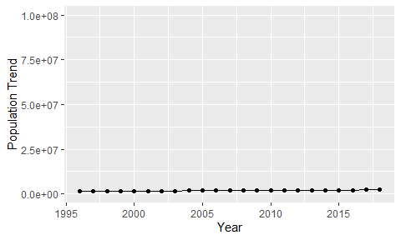

Political Stability Trend

# Population growth graph

The plot shows the population growth rate trend of the country.

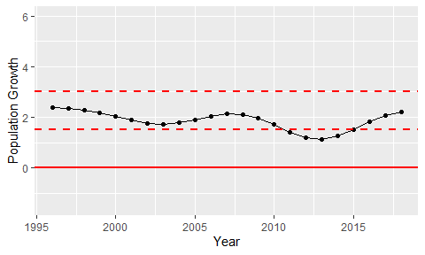

Population Growth Trend